Coastal picocyanobacteria can exploit low oxygen habitats

Sylwia Śliwińska-Wilczewska1,2, Mireille Savoie1, Naaman M. Omar1, and Douglas A. Campbell1,✉

1 Department of Biology, Mount Allison University, 53 York St., Sackville, NB, E4L 1C9, Canada  
2 Institute of Oceanography, University of Gdansk, 46 Pilsudskiego St, P81-378, Gdynia, Poland

✉ Correspondence: [Douglas A. Campbell <[dubhglascambeuil@gmail.com](mailto:dubhglascambeuil@gmail.com)>](mailto:dubhglascambeuil@gmail.com)

# Abstract

xxx

# Introduction

Oxygen is essential for the survival of organisms and regulates the global cycling of nutrients and carbon. Oxygen levels in the open ocean and coastal waters have declined over the past half-century due to human activities that increase global temperatures and nutrient release. These factors accelerated microbial respiration, reduced the solubility of oxygen in water, and reduced the rate of oxygen re-supply from the atmosphere to the ocean, resulting in significant biological and ecological consequences. Since the mid-20th century, ocean deoxygenation has become a critical change in marine ecosystems, affecting productivity, biodiversity and biogeochemical cycles. This ocean deoxygenation ranks among the most important changes occurring in marine ecosystems [xxxx]. Historical data link major extinction events to warm climates and oxygen-deficient oceans, suggesting that current anthropogenic activities could lead to widespread oxygen deficiency in the oceans within a thousand years. Over the past 50 years, the open ocean has lost about 2% of oxygen, and models predict a further decline of several percent by the end of the century, which could cause significant biogeochemical and ecological impacts. Oxygen minimum zones (OMZs) in the open ocean have expanded to an area equivalent to the European Union, and the volume of oxygen-free water has quadrupled. But the paradox is that these areas, sometimes called dead zones, are far from dead (Breitburg et al. 2018).

xxx Add (Wong et al. 2023), (Ulloa et al. 2012).

Picocyanobacteria, the most abundant primary producers in marine ecosystems (Flombaum et al. 2013), exhibit remarkable adaptations to thrive in low oxygen environments, such as Oxygen Minimum Zones (OMZs), prevalent at depths in the ocean (Wong et al. 2023). These zones are characterized by exceptionally low dissolved oxygen concentrations, posing challenges for aerobic organisms. However, picocyanobacteria species have evolved diverse strategies to cope with these conditions. Picocyanobacteria, can perform photosynthesis under extremely low light and oxygen levels, utilizing specialized pigments and photosystems to capture and utilize light energy efficiently [XXX citations xxx]. Furthermore, recent studies have highlighted the role of specific genetic adaptations in cyanobacteria populations inhabiting OMZs, enabling them to tolerate and even thrive in oxygen-depleted environments (Ulloa et al. 2012). These adaptations encompass genetic modifications related to energy metabolism, antioxidant defense mechanisms, and cellular structures optimized for oxygen scavenging and storage. Overall, the occurrence and adaptation of picocyanobacteria to low oxygen environments are critical components of marine ecosystems, shaping their productivity and biodiversity in OMZ regions.

xxx Add info about Colour Light and pico XXX

The aim of this work was to demonstrate the ecophysiological response of PC-rich and PE-rich *Synechococcus* sp. to different oxygen concentrations and colors of light.

# Materials and Methods

## Culture condition and experimental setup

Xenic cultures of PC-rich (CCBA_077) and PE-rich (CCBA_127) *Synechococcus* sp. were obtained from the Culture Collection of Baltic Algae (<https://ccba.ug.edu.pl/pages/en/home.php>) [XXX Latala et al., 2006 - soon in zotero]. *Synechococcus* sp. strains were cultured in Tissue Culture Flasks (VWR International, Cat. No. 10062-872, PA, USA) and transferred biweekly to fresh f/2 media (Guillard 1975) prepared at a salinity of 8 PSU, reflective of their natural habitat. Pre-cultures were maintained in incubators set to full air saturated dissolved oxygen concentration of 250 µM, temperature of 22℃ with a light/dark cycle of 12 h and Photosynthetically Active Radiation (PAR) of 10 µmol photons m−2s−1 with illumination from Philips Cool White F14T5/841 Alto, 14 watts, fluorescent bulbs.

Controlled growth experiments were performed using MCMIX-OD PSI Multicultivators (Photon Systems Instruments, Drásov, Czech Republic) set to 22℃. Each of 8 round bottom cylindrical glass tubes contained 75 mL of f/2 medium and 5 mL of growing pre-culture. These parameters allowed for exponential growth of the cultures from the beginning of the experiment, with little lag phase. Inoculation of culture tubes took place in the afternoon, with a period of low light and then 12 h darkness before a sinusoidal 12 h photoperiod cycle commenced at 7:00 AM the following morning, with peak PAR of 180 µmol photons m−2s−1 reached at 1:00 PM each day.

Each tube was maintained under an individual combination of one of 7 spectral wavebands (centred at 405, 450, 470, 530, 620, 660, or 730 nm) and 2 dissolved oxygen concentrations (O2; 250 µM and 2.5 µM). Culture tubes were closed with a silicone inert silicone stopper perforated by an aeration input tube extending to the bottom of the culture tube, and a pressure outlet tube. We used aeration with a total gas flow rate of around ~ 140 mL min−1 tube−1 through a 0.2µm sterile microfilter via a G400 gas mixing system (Qubit Systems Inc., Kingston, Ontario, Canada). The high dissolved O2 concentration of ~ 250 µM was achieved by sparging with lab air (78% N2, 21% O2, 1% Ar and 0.05% CO2). The low dissovled O2 concentration of ~ 2.5 µM, was achieved by sparging with a gas mixture containing 99.95% N2 and 0.05% CO2. O2 concentrations *in situ* were verified using oxygen optodes (PyroScience, Germany) inserted into tubes for real-time measurements (data not presented), wiht software correctiong to account for the salinity of the media (8 PSU). The pH of tested cultures remained about 8, with limited fluctuation during the experiment (data not presented).

## Chlorophyll-specific growth rates

Picocyanobacterial growth was monitored every 5 minutes by automatically recording OD680, OD720, and ΔOD (ΔOD = OD680 – OD720) for at least 5 days, independently for each culture tube. The chlorophyll-specific growth rates (µ) were determined by fitting logistic growth curves using a modified Levenberg-Marquardt fitting algorithm (Elzhov et al. 2023) to plots of the chlorophyll *a* proxy of ΔOD vs. elapsed time (d) for each combination of strain, spectral waveband, and O2 concentration. Growth curves, tracked as OD680, OD720, ΔOD and logistic fits of ΔOD vs. elapsed time are shown in Fig. S1 in Supplementary materials. Cell-specific growth rates (µ) were also determined using OD720 (Fig. S2).

## Picocyanobacteria cell counts

Picocyanobacterial cells mL-1 were estimated using linear regression models of OD at 680 nm or 720 nm vs. calibration counts of cell suspension densities (cell mL−1) (Table S1). The OD of cultures was measured using MCMIX-OD PSI Multicultivators (Photon Systems Instruments, Drásov, Czech Republic) and cell suspension density measures were conducted using an ImageXpress Pico Digital microscope equipped with CMOS camera and LED+ image autofocus (ImageXpress Pico Automated Cell Imaging System, Molecular Devices, LLC., CA, USA). Culture samples were preserved with 4% glutaraldehyde and kept at -80°C until the microscopy measures. Fixed samples of culture (V = 10 µL) were transferred to Tissue Culture (TC)-treated surface, flat bottom black 96-well plates (Corning® Falcon® Microplate, MilliporeSigma, Merck, Darmstadt, Germany) containing 200 µL of f/2 media and centrifuged using a Beckman J-20 centrifuge with a swinging bucket JS-4.3 rotor at 4500 rpm (Beckman Coulter, Brea, California, United States). Cells were imaged with the Cy5 channels (Excitation: 630/40 nm; Emission: 695/45 nm; Dichroic: 655 nm) using selectable confocal geometries, which allowed us to distinguish cyanobacterial cells from co-occurring heterotrophic bacteria, and counted using a 63x objective in fluorescence imaging modes. Quantitative analysis on images acquired from automated microscopy obtained from 96-well microplates was performed using CellReporterXpress Image Acquisition and Analysis Software. The actual cell number mL-1 was calculated based on the dilution factor and selected count area from each well (Wlodkowic et al. 2022).

## Pigment content and pigment ratio

Whole-cell absorbance spectra of picocyanobacteria cells were collected using an integrating cavity spectrophotometer (CLARiTY 17 UV/Vis/NIR, On-Line Instrument Systems, Inc., Bogart, GA, USA) according to the method proposed by Blake and Griff (2012). The sample and reference observation cavities of the spectrophotometer were filled with 8 mL of f/2 medium at salinity 8 PSU. After establishing a baseline absorbance spectra from 375 to 710 nm, 4 mL culture medium was replaced with 4 mL of culture in the sample cavity. Pathlength corrected absorbance per cm was calculated using Jávorfi coefficients (Jávorfi et al. 2006). We then conducted estimations of pigment content (µg mL-1) including Chlorophyll *a* (Chl *a*), Carotenoids (Car), Phycoerythrin (PE), Phycocyanin (PC), and Allophycocyanin (APC) from the PC-rich_077 and PE-rich_127 *Synechococcus* sp. cultures. These estimations were based on established linear correlations between pigment content, determined through extraction methods (Strickland and Parsons 1972; Bennett and Bogorad 1973), and absorbance values of individual pigment peaks (Car; 480 nm, PE; 565 nm, PC; 620 nm, APC; 650 nm, and Chl *a*; 665 nm) obtained from whole-cell absorbance spectra (Table S2). We also summed PE, PC, and APC protein to total Phycobiliprotein content. We then calculated the Car to Chl *a* ratio and the ratio of the sum of Phycobiliproteins to Chl *a* (µg:µg) for each strain (Fig. S3).

## PSII effective absorption cross section of PSII, turnover time of PSII photochemistry, and photochemical quenching coefficient

We harvested 4 mL of picocyanobacteria cultures for photophysiological characterizations repeatedly across the growth trajectories. For the low oxygen cultures, to ensure functional measurements were taken at low O2 of ~ 2.5 µM, we bubbled gently with N2 from a gas cylinder during measurements. O2 concentration was verified using oxygen optodes (PyroScience, Germany) inserted into culture samples for functional measurements (data not presented).

We used Fast Repetition & Relaxation chlorophyll fluorescence (FRRf) (Kolber et al. 1998) (Solisense, USA), with a lab built temperature control jacket (22℃), to apply a series of XX excitation flashlets of 1.2 µs to drive saturation, followed immediately by logarithmically spaced flashlets to track relaxation, fit using the onboard Solisense LIFT software (Falkowski and Kolber 1993; Kolber et al. 1998).

We used a double tap protocol (Xu et al. 2017), where FRRf induction/relaxation trajectories were collected during a rapid actinic light curve sequence increasing in steps of 10 s at 0, 20, 40, 80, 160, and 320 µmol photons m−2s−1 PAR. We applied 1 s darkness between the sequential 10 s steps of the light response curves, to allow re-opening of PSII. Flashlets and actinic light were delivered from LED emitters centred at 445, preferentially exciting chlorophyll; 470, preferentially exciting phycourobilin (PUB); 530, preferentially exciting phycoerythrin (PE); or 590 nm, preferentially exciting phycocyanin (PC). Excitation flashlets and actinic light wavebands were matched for each run. These actinic and excitation wavebands in turn approximated 4 of our 7 growth light wavebands (450, 470, 530 & 620 nm), allowing us to evaluate *in situ* photosynthetic performance for those cultures.

Flashlet power delivered to the samples during the 1.2 µs flashlet duration was adjusted to achieve saturation of variable fluorescence; Ex445nm at 60000 µmol photons m−2s−1 PAR; Ex470nm and Ex535nm at 25000 µmol photons m−2s−1 PAR; while for Ex590nm excitation power at 14000 µmol photons m−2s−1, calibrated using a quantum sensor (LI-250, LI-COR, Inc.) in the temperature controlled cuvette.

We estimated effective absorption cross section of PSII (σPSII; nm2 quanta−1); turnover time of PSII photochemistry (τPSII; µs); and the photochemical quenching coefficient (qP) XXXXCITATION using the FRRf induction curves, following (Xu et al. 2017).

## PSII electron flux

We calculated (Eq. (1)) an uncalibrated fluorescence based estimator for volumetric electron transport, *JV*PSII, (k × e− L−1 s−1) under Ex445nm, blue; Ex470nm, blue-green; Ex535nm, green; or Ex590nm, orange excitation bands (Oxborough et al. 2012; Boatman et al. 2019; Tortell and Suggett 2021).

$$JV_{PSII}=\frac{σ_{PSII}′×qP×I×F_{O}}{σ_{PSII}} \left(1\right)$$

where σPSII′ is effective absorption cross section for PSII photochemistry under the relevant actinic PAR step (nm2 quanta−1); qP is an estimate of the fraction of PSII open for photochemistry estimated according to Oxborough and Baker (1997); I is the applied PAR (µmol photons m−2s−1); *F*O is the minimum fluorescence from a given sample and excitation waveband (relative fluorescence) and σPSII is the maximum effective absorption cross section for PSII photochemistry from a given sample and excitation waveband (nm2 quanta−1).

We calibrated the *JV*PSII estimator to absolute rates of electron transport (Eq. (2)) using parallel measures of oxygen evolution (µmol O2 L−1 s−1), captured simultaneously with the FRRf measures, taken below light saturation of electron transport to limit distortion from electron fluxes back to oxygen under super-saturating light XXXhttps://pubs.acs.org/doi/full/10.1021/acs.est.8b03488XXXX, using a FireSting robust oxygen probe (PyroScience, Germany) inserted in the cuvette for select Rapid Light Curve (RLC) runs (Table S3).

$$JV_{PSII}\left(e^{−} L^{−1} s^{−1}\right)=\frac{Uncalibrated JV_{PSII}\left(e^{−} L^{−1} s^{−1}\right)}{Calibration slope} \left(2\right)$$

XXXXMAYBE WE SHOULD ADD JVPSII to the LIGHT RESPONSE FUNCTIONAL FIGURE???XXXX

For the samples on whichFRRf measurements were performed, Chl *a* (µg mL−1) was also measured using Trilogy Laboratory Fluorometer (Turner Designs, Inc., CA, USA) equipped with Chlorophyll In-Vivo Module. Quantitative analysis of Chl *a* was obtained after adding 50 µL of picocyanobacteria culture and 2 mL of a 90% acetone:DMSO solution in a 3:2 ratio.

## Statistical analysis

We used R version 4.3.0 (R Core Team 2023) running under RStudio (Posit team 2022). We performed three-way factorial ANOVA (*aov()* function; R Base package) to determine whether strain, growth waveband, O2 concentration, and their interactions, significantly influence the chlorophyll-specific growth rate (µ; d−1; Tab. S4) vs. pigment content (Tab. S5). We also performed three-way factorial ANOVA (*aov()* function) to determine whether strain, Actinic PAR, O2 concentration, and their interactions, significantly influence the responses of σPSII (Tab. S6); τPSII (Tab. S7); or qP to increasing light (Tab. S8).

We used *t*-tests of linear fits to compare data across different strains and O2 concentrations for a given growth waveband, for chlorophyll-specific growth rate vs. Phycobiliproteins to Chl *a* ratio (Tab. S9). We also performed *t*-tests of linear fits to compare data across different strains and O2 concentration in situations in which cultures were excited by, and growing in, corresponding growth wavebands of 450, 470, 530, or 620 nm, for chlorophyll-specific growth rate vs. *JV*PSII (Tab. S10). Statistical differences for all analyses were determined at significance level α = 0.05.

The manuscript was prepared as a Rmarkdown document (Handel 2020) with figures plotted using ggplot2 (Wickham 2016) and patchwork (Pedersen 2024) packages. All metadata, data, and code is available on GitHub (<https://github.com/FundyPhytoPhys/BalticO2>), and data is available on XXXXRESPOSITORY??? BOREALIS?????.

# Results

## Chlorophyll-specific growth rates

We used logistic curve fits (Fig. S1) to determine chlorophyll-specific growth rates (μ; d−1), for PC-rich and PE-rich cultures of *Synechococcus* sp. grown at spectral wavebands of 405, 450, 470, 530, 620, 660, or 730 nm and O2 concentrations of 250 µM or 2.5 µM (Fig. 1. Cell-specific growth rates (µ) were also determined using OD720 (Fig. S2).

Three-way factorial ANOVA showed that strain, growth waveband, O2 concentration, and their interactions, significantly affected μ (ANOVA, *p* < 0.05 for all; Table S4).

We have shown that PC-rich and PE-rich *Synechococcus* sp. are able to grow in low O2 condition in the entire range of tested spectral wavebands (405 – 730 nm). On the other hand, in the presence of high O2 concentrations (250 µM), PC-rich strain did not show growth at 405 nm and PE-rich strain did not growth at 405, 450, and 730 nm. What is more, PE-rich strains achieved faster growth rates under O2 concentration of 2.5 µM than 250 µM whereas, PC-rich strain showed similar growth rates under 250 µM and 2.5 µM of O2 concentration across tested spectral waveband (nm).

PC-rich *Synechococcus* sp. showed distinct growth peak at red light where μ = 0.165 ± 0.030 d−1 at 620 nm and μ = 0.164 ± 0.032 d−1 at 660 nm under O2 concentration of 250 µM and μ = 0.137 ± 0.026 d−1 at 620 nm and μ = 0.141 ± 0.028 d−1 at 660 nm) under O2 concentration of 2.5 µM. Under O2 concentration of 2.5 µM, PE-rich strain showed high growth rates under 530 nm (μ = 0.181 ± 0.021 d−1), 620 nm (μ = 0.184 ± 0.019 d−1) and 660 nm (μ = 0.180 ± 0.019 d−1). Under 250 µM of O2, PE-rich strain showed the highest growth rate under green light at 530 nm (μ = 0.131 ± 0.046 d−1).

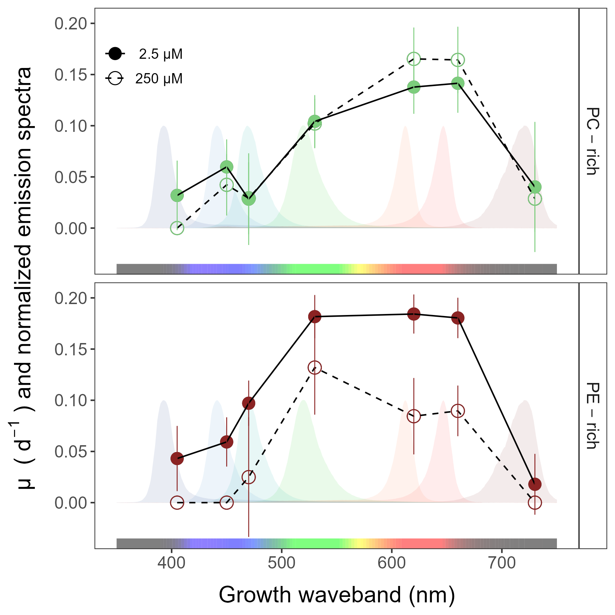

**Fig.** 1: Chlorophyll-specific growth rates (µ; d−1) vs. growth waveband (nm, shaded regions). Growth rates (± SE) were estimated from logistic fits of chlorophyll proxy OD680 – OD720 (ΔOD) vs. elapsed time (Fig. S1), for PC-rich (green circle) and PE-rich (red circle) cultures of *Synechococcus* sp. grown at spectral wavebands of 405, 450, 470, 530, 620, 660, or 730 nm, and O2 concentrations of 250 µM (open symbols and dashed line) or 2.5 µM (closed symbols and solid line).

## Pigment content and pigment ratio

Fig. 2*a* presents Chlorophyll *a* (Chl *a*), Phycobiliproteins (Phyco), or Carotenoids (Car) content (pg cell −1) vs. growth waveband (nm) for PC-rich and PE-rich cultures of *Synechococcus* sp. grown at spectral wavebands of 405, 450, 470, 530, 620, 660, or 730 nm and O2 concentrations of 250 µM or 2.5 µM. Here, we not presented data for those PE-rich cultures which showed negligible growth under 405, 450, 730 nm and 250 µM O2; nor for those PC-rich cultures which showed negligible growth under 405 nm and 250 µM O2.

Three-way factorial ANOVA showed that strain, growth waveband, O2 concentration, and their interactions, significantly affected cell-specific Chl *a*, Phyco, or Car content (ANOVA, *p* < 0.05 for all; Table S5). We showed that O2 concentration had little visible effect on the Chl *a* and Car content of PC-rich and PE-rich picocyanobacteria. For PC-rich strain, the highest Chl *a*, Phyco, and Car content was recorded at 730 nm. Moreover, the Phyco content was higher under O2 concentration of 250 µM than 2.5 µM for PC-rich culture. On the other hand, we noted that for PE-rich cultures of *Synechococcus* sp. Phyco content was significantly higher in conditions of low O2 concentration than high O2 concentration. For this strain, the highest Phyco content was noted under red spectral waveband of 620 nm and 2.5 µM and was XXXX pg cell −1.

Here, we also presented linear regressions between chlorophyll-specific growth rates (µ; d−1) and Phycobiliproteins:Chlorophyll *a* ratio (µg:µg) for PC-rich and PE-rich *Synechococcus* sp. grown at spectral wavebands of 405, 450, 470, 530, 620, 660, or 730 nm and O2 concentrations of 250 µM or 2.5 µM (Fig. 2*b*). We have shown that the ratio of phycobiliproteins to Chlorophyll *a* positively affects µ of the tested picocyanobacteria. Moreover, we showed that for the PC-rich strain, no statistical differences were found between data sets fitted across 2.5 µM and 250 µM O2 (*t*-test; *p* > 0.05, Tab S.9). On the other hand, PE-rich culture showed strong statistical differences between the fit model plotted in O2 concentrations of 2.5 and 250 µM (*t*-test; *p* < 0.05, Tab S.9). What is more, when comparing PC-rich and PE-rich strains together, differences between low and high O2 concentrations were also demonstrated (*t*-test; *p* < 0.05, Tab S.9).

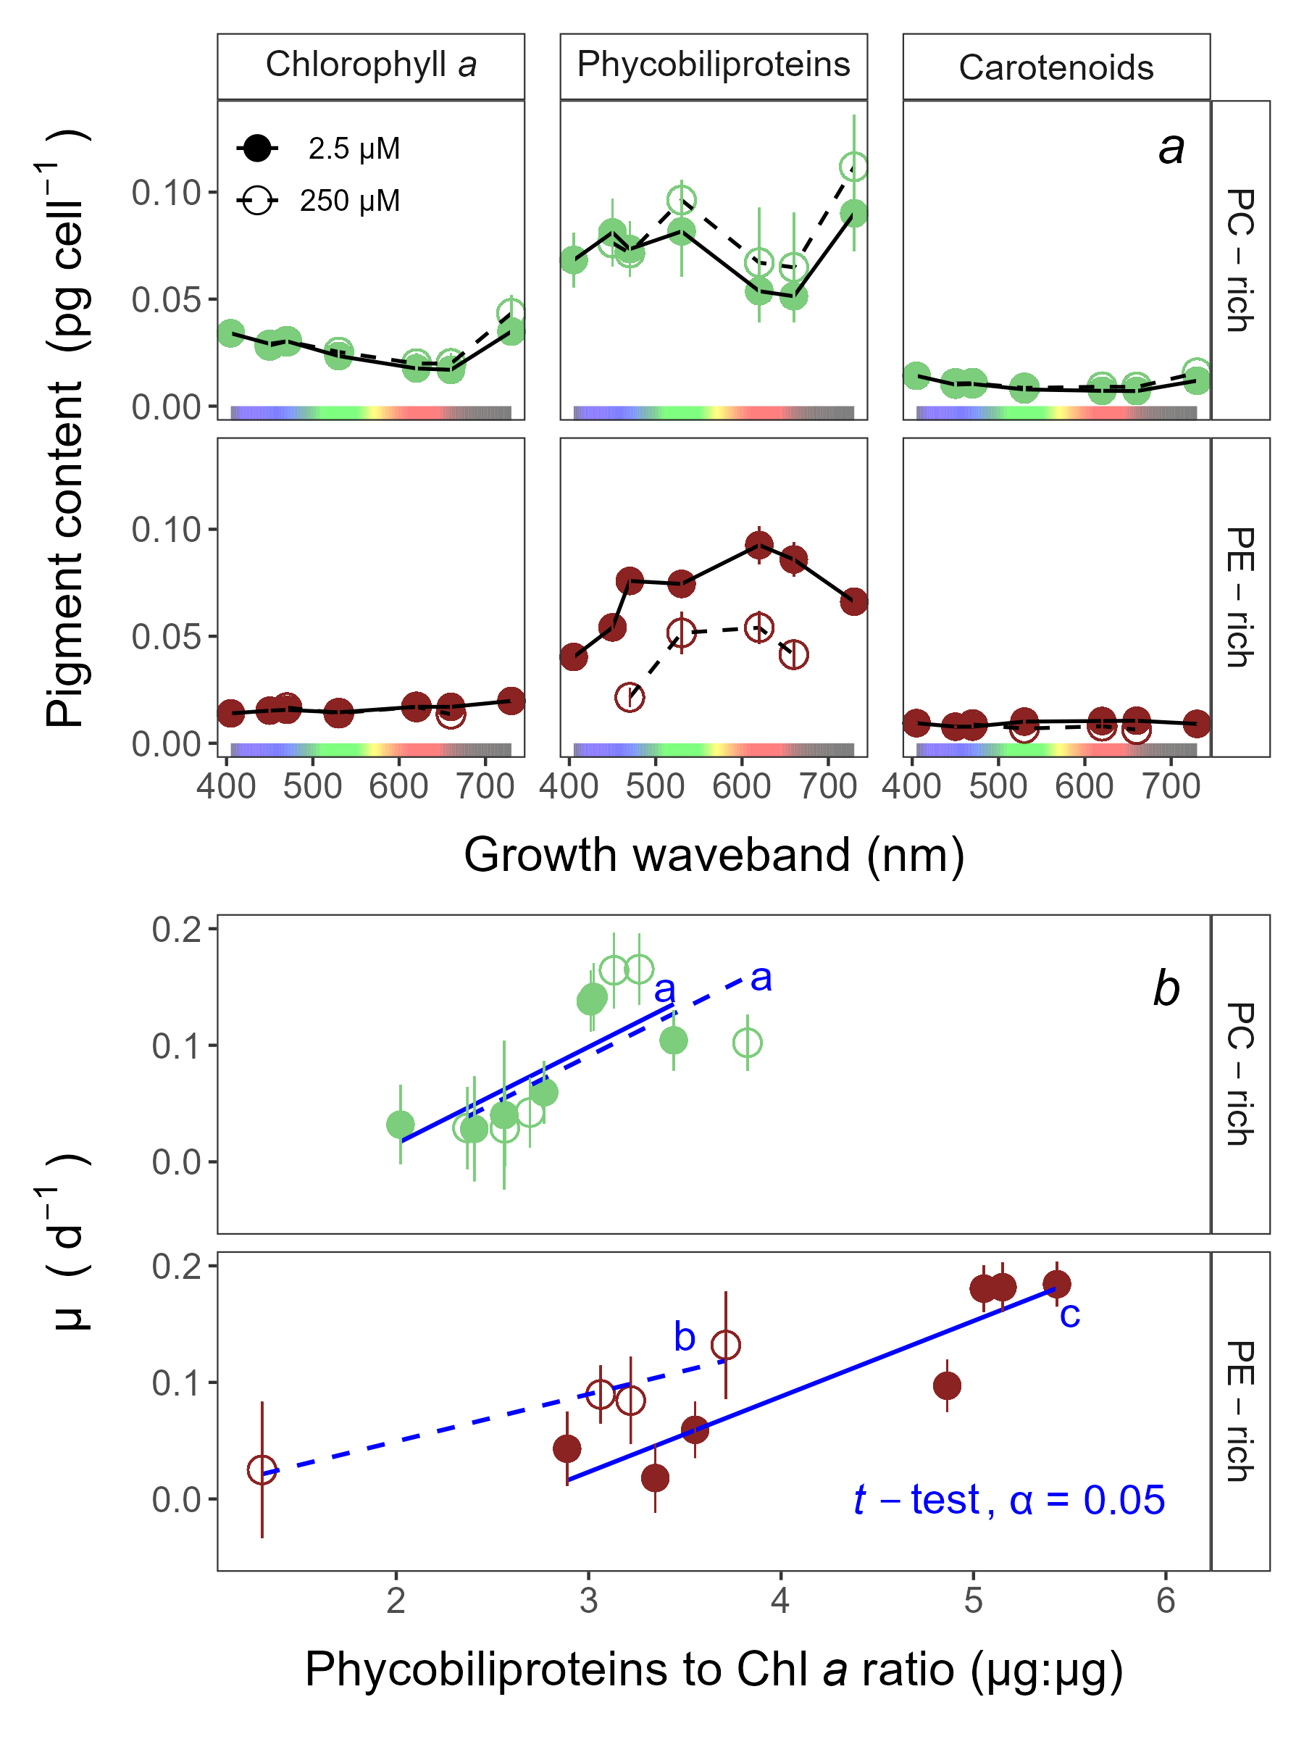

**Fig.** 2: Pigment content (pg cell −1) vs. growth waveband (nm; *a*) and Chlorophyll-specific growth rates (µ; d−1) vs. Phycobiliproteins:Chlorophyll *a* ratio (µg:µg) (*b*) for PC-rich (green circle) and PE-rich (red circle) cultures of *Synechococcus* sp. grown at spectral wavebands of 405, 450, 470, 530, 620, 660, or 730 nm and O2 concentrations of 250 µM (open symbols and dashed line) or 2.5 µM (closed symbols and solid line). Data not presented for those PE-rich cultures which showed negligible growth under 405, 450, 730 nm and 250 µM O2; nor for those PC-rich cultures which showed negligible growth under 405 nm and 250 µM O2. Blue lines shows linear model fit for data from each strain and O2 (solid for 2.5 µM O2 or dashed for 250 µM O2) across spectral wavebands. Different blue lowercase letters indicate statistically significant differences between the fit models for different strains or given O2 concentrations (*t*-test; *p* < 0.05).

## Effective absorption cross section of PSII, turnover time of PSII photochemistry, and photochemical quenching coefficient

The effective absorption cross section of PSII (σPSII; nm2 quanta−1); turnover time of PSII photochemistry (τPSII; µs); or photochemical quenching coefficient (qP) vs. Actinic PAR (µmol photons m−2s−1) was shown in Fig. 3*a-c*). Those parameters were estimated using FRRf induction curves with excitation at Ex445nm, blue; Ex470nm, blue-green; Ex535nm, green; or Ex590nm, orange. Data show situations in which PC-rich and PE-rich cultures were excited by, and growing in, corresponding growth wavebands of 450, 470, 530, or 620 nm and O2 concentrations of 250 µM or 2.5 µM. Please note, we not presented data for those PE-rich cultures which showed negligible growth under 405, 450, 730 nm and 250 µM O2; nor for those PC-rich cultures which showed negligible growth under 405 nm and 250 µM O2. In the Supplementary materials (Fig S4-S6), we also showed the same data determined for all excitations (Ex445nm, blue; Ex470nm, blue-green; Ex535nm, green; or Ex590nm, orange) and growth wavebands (450, 470, 530, or 620 nm) combinations.

We demonstrated that σPSII (Fig. 3*a*), as expected, shows no changes during excitation at Ex445nm and Ex440nm for PC-rich and PE-rich strains. For PC-rich, under orange excitation at Ex590nm, σPSII showed a mild decrease with increasing Actinic PAR and was higher at 250 µM O2 compared to 2.5 µM O2. In turn, for the PE-rich strain, a drastic decrease in σPSII was noted with an increase in Actinic PAR. Moreover, σPSII was higher in low O2 conditions than in high O2 conditions. σPSII showed was higher for PE-rich culture at Ex535nm and Ex590nm than for PC-rich strain. What is more, three-way factorial ANOVA also showed that strain, Actinic PAR, O2 concentration, but not their interactions, significantly affected σPSII under excitation at Ex590nm (ANOVA, *p* < 0.05; Table S6).

For PC-rich culture, regardless of the used excitation, τPSII showed a decrease at low Actinic PAR and reached a plateau with increasing light (Fig. 3*b*). PE-rich strains, on the other hand, showed a strong decrease with increasing Actinic PAR under excitation at Ex470nm, Ex535nm, or Ex590nm. We also showed that τPSII, was generally higher for both PC-rich and PE-rich strains under O2 concentrations of 2.5 µM. Three-way factorial ANOVA showed that strain, Actinic PAR, O2 concentration, but not their interactions, significantly affected τPSII at Ex470nm and Ex535nm (ANOVA, *p* < 0.05; Table S7). What is more, strain, Actinic PAR, O2 concentration, and their interactions significantly affected τPSII at Ex590nm (ANOVA, *p* < 0.05; Table S7).

qP, regardless of the excitation tested, showed a strong decrease with increasing Actinic PAR (Fig. 3*c*). Interestingly, qP was generally higher for both PC-rich and PE-rich strains under O2 concentrations of 250 µM. Three-way factorial ANOVA showed that strain, Actinic PAR, O2 concentration, but not their interactions, significantly affected qP at at Ex470nm, Ex535nm, or Ex590nm (ANOVA, *p* < 0.05 for all; Table S8).

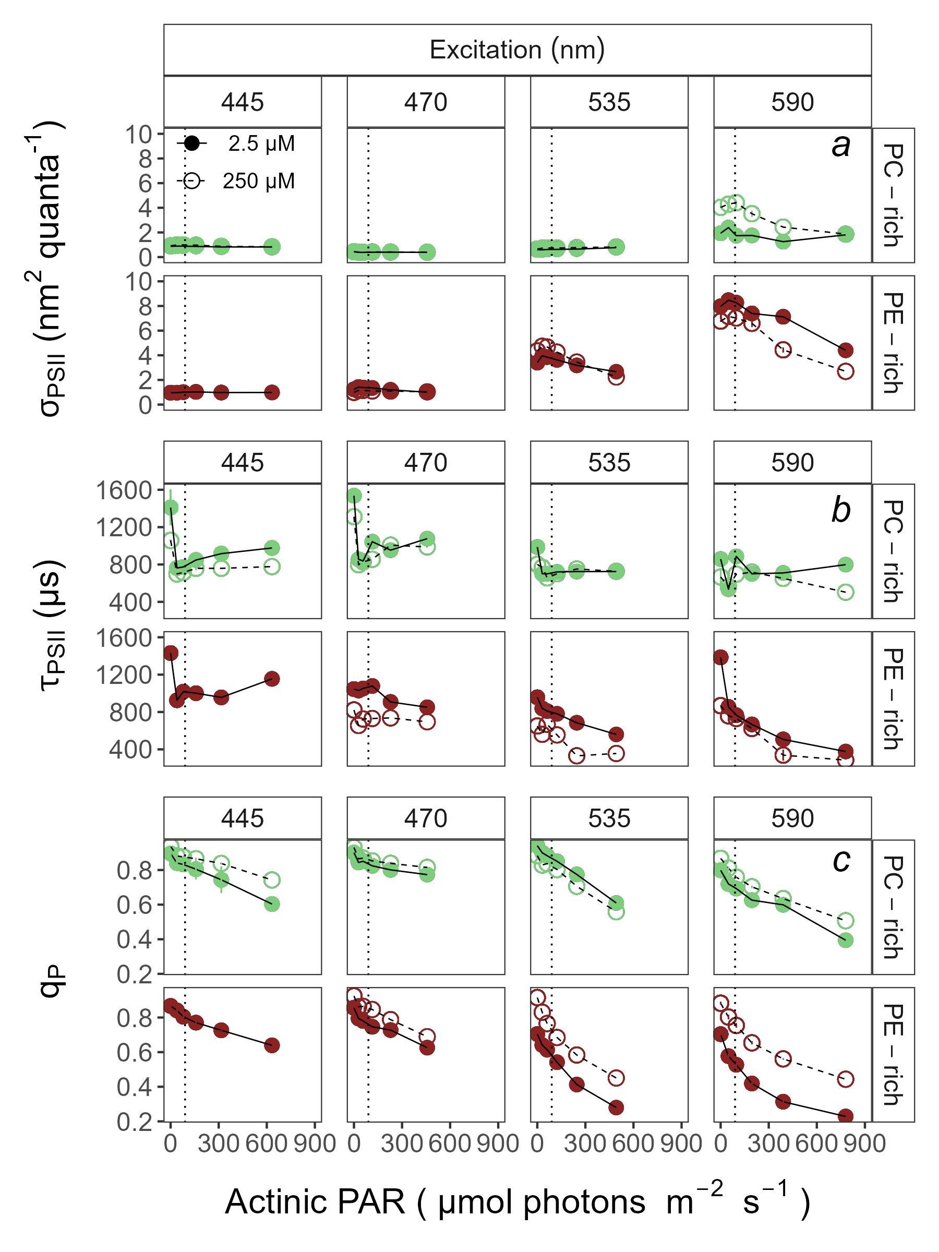

**Fig.** 3: Effective absorption cross section of PSII (σPSII; nm2 quanta−1, *a*); turnover time of PSII photochemistry (τPSII; µs, *b*); or photochemical quenching coefficient (qP, *c*) vs. Actinic PAR (µmol photons m−2s−1). Parameters were estimated using FRRf induction curves with excitation (columns) at Ex445nm, blue; Ex470nm, blue-green; Ex535nm, green; or Ex590nm, orange; for PC-rich (green circle) or PE-rich (red circle) cultures of *Synechococcus* sp. Data show situations in which cultures were excited by, and growing in, corresponding growth wavebands of 450, 470, 530, or 620 nm and O2 concentrations of 250 µM (open symbols and dashed line) or 2.5 µM (closed symbols and solid line). The vertical lines show half diel peak PAR growth light of 90 µmol photons m−2s−1. Data not presented for those PE-rich cultures which showed negligible growth under 405, 450, 730 nm and 250 µM O2; nor for those PC-rich cultures which showed negligible growth under 405 nm and 250 µM O2.

## Growth rates vs. cumulative diel PSII electron flux

Fig. 4 presents linear regressions between chlorophyll-specific growth rates (µ; d−1) and PSII electron flux (*JV*PSII; µmol e− µmol Chl *a*−1 d−1) measured under half diel peak PAR growth light. *JV*PSII was estimated using FRRf induction curves with excitation at Ex445nm, Ex470nm, Ex535nm, or Ex590nm. Data show situations in which PC-rich and PE-rich cultures were excited by, and growing in, corresponding growth wavebands of 450, 470, 530, or 620 nm and O2 concentrations of 250 µM or 2.5 µM. We not presented data for those PE-rich cultures which showed negligible growth under 405, 450, 730 nm and 250 µM O2; nor for those PC-rich cultures which showed negligible growth under 405 nm and 250 µM O2.

We have shown that the *JV*PSII positively affects µ of the tested PE-rich picocyanobacteria? XXX Stop here, need stats firstXXX

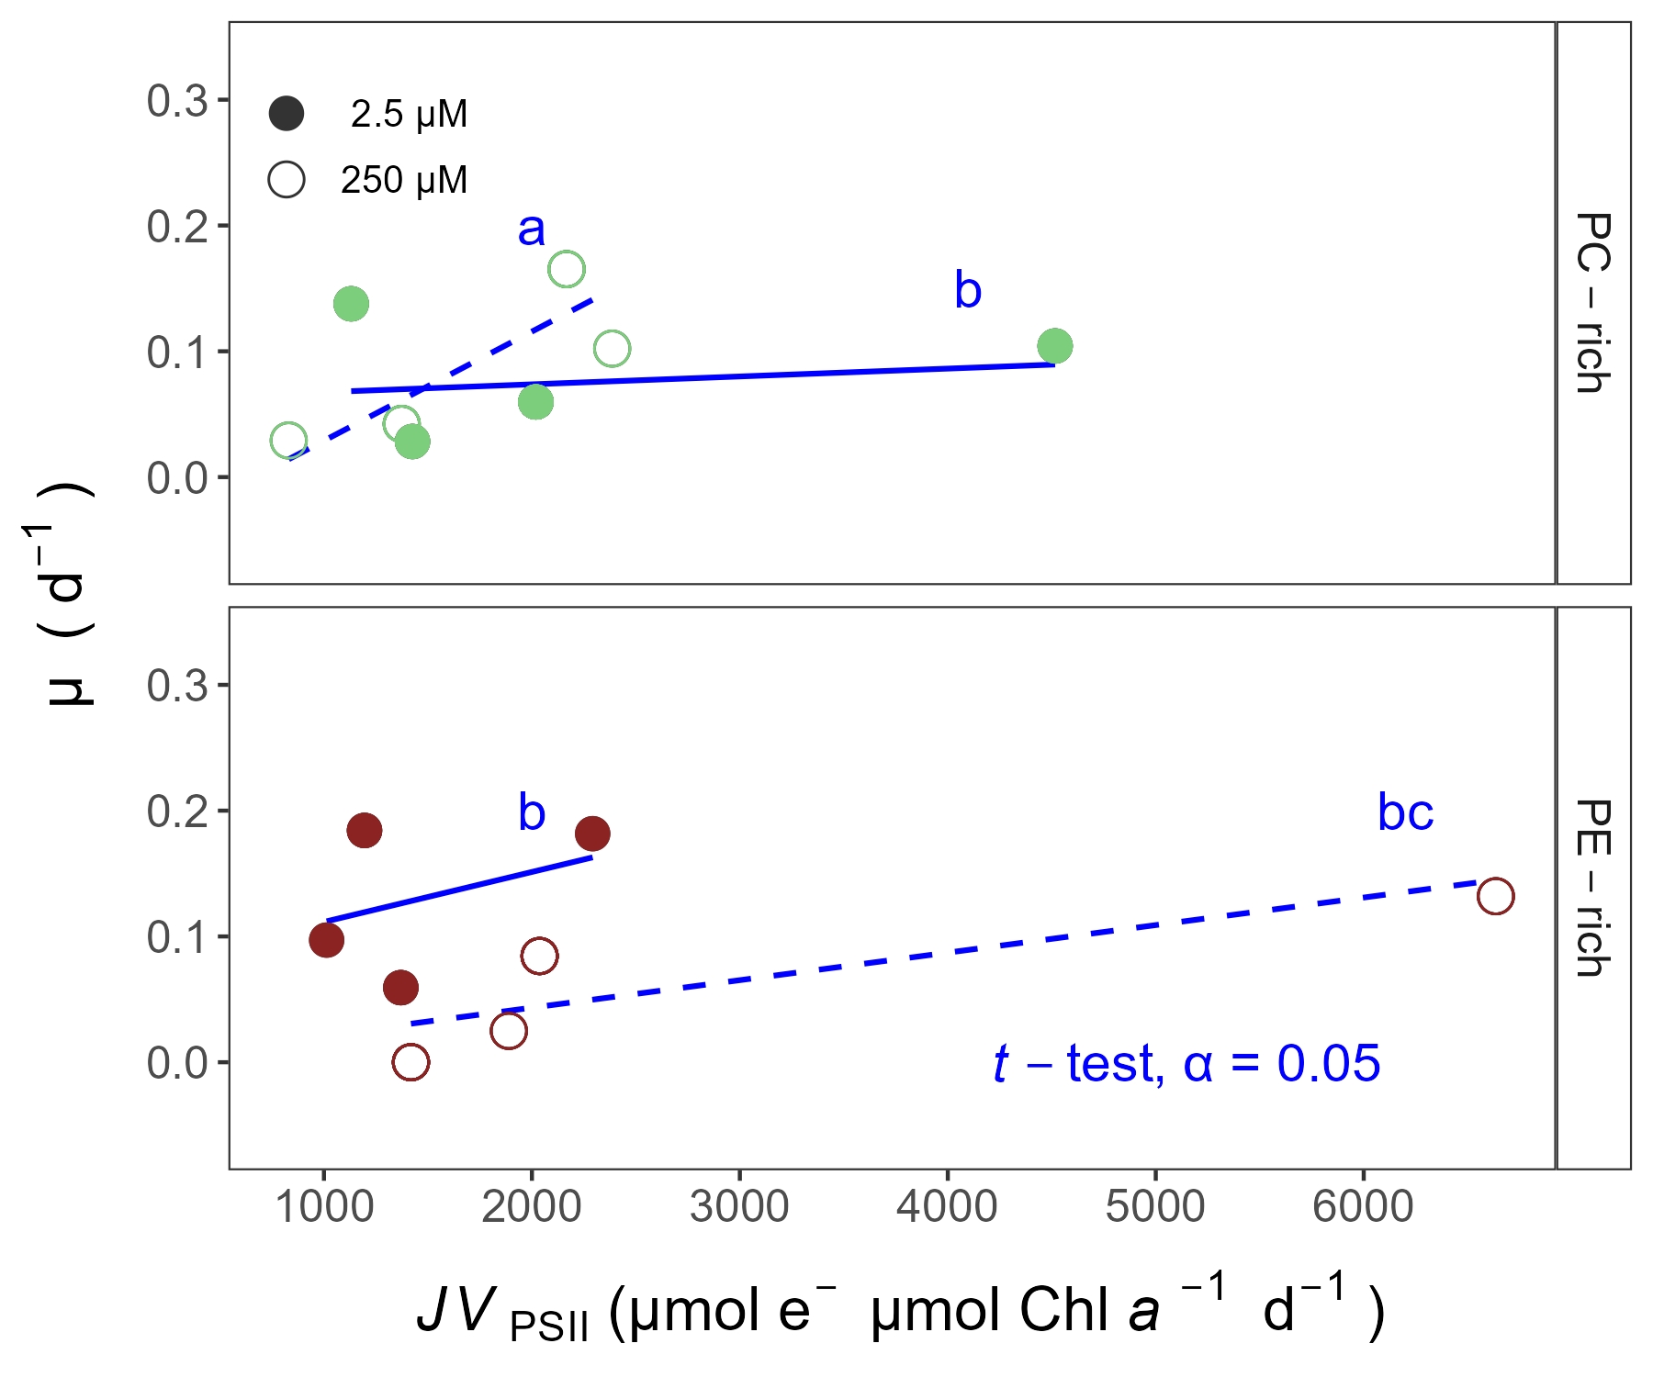

**Fig.** 4: Chlorophyll-specific growth rates (µ; d−1) vs. PSII electron flux (*JV*PSII; µmol e− µmol Chl *a*−1 d−1) measured under half diel peak PAR growth light. Growth rates (± SE) were estimated from logistic fits of chlorophyll proxy OD680 - OD720 (ΔOD) vs. elapsed time (Fig. S1). *JV*PSII was estimated using FRRf induction curves with excitation at Ex445nm, blue; Ex470nm, blue-green; Ex535nm, green; or Ex590nm, orange; for PC-rich (green circle) or PE-rich (red circle) cultures of *Synechococcus* sp. Data show situations in which cultures were excited by, and growing in, corresponding growth wavebands of 450, 470, 530, or 620 nm and O2 concentrations of 250 µM (open symbols and dashed line) or 2.5 µM (closed symbols and solid line). Blue lines (solid for 2.5 µM O2 or dashed for 250 µM O2) shows linear model fit for data from each strain across spectral wavebands. Different blue lowercase letters indicate statistically significant differences between the fit models for different strains or given O2 concentrations (*t*-test; *p* < 0.05).

# Discussion

# Conclusions

**Additional Supporting Information may be found in the online version of this article.**

**Authors Contribution Statement:** S.S-W. designed the study with input from D.A.C. M.S. ensured the proper operation of the photobioreactors. N.M.O. solved technical problems related to computer operation and software. S.S-W., M.S., N.M.O., D.A.C. contributed to R coding and data analysis. S.S-W. conducted the experiments, created plots and wrote the manuscript, with support from D.A.C. All authors contributed to the discussion of the results, supported manuscript preparation, and approved the final submitted manuscript.

# Data availability statement

Data supporting this study is available on: <https://github.com/FundyPhytoPhys/BalticO2> (public GitHub Repository) and <https://docs.google.com/spreadsheets/d/1ZXpwR7Gfto-uRzVdXzMpQF4frbrvMLH_IyLqonFZRSw/edit#gid=0> (URL for MetaDataCatalog).

Code to perform data processing and analyses is available at <https://github.com/FundyPhytoPhys/BalticO2>.

## Acknowledgements

We thank Miranda Corkum who maintained cultures and trained personnel in culture handling; Laurel Genge, and Carlie Barnhill (Mount Allison students) who assisted with R code. This work was supported by Canada Research Chair in Phytoplankton Ecophysiology (D.A.C) and Latitude & Light; NSERC of Canada Discovery Grant (D.A.C).

## Conflict of Interest

None declared.

Competing interests: The authors declare there are no competing interests.

# References

Bennett, A., and Bogorad, L. 1973. Complementary Chromatic Adaptation in a filamentous blue-green alga. Journal of Cell Biology **58**(2): 419–435. doi:[10.1083/jcb.58.2.419](https://doi.org/10.1083/jcb.58.2.419).

Blake, R., and Griff, M. 2012. In situ spectroscopy on intact *Leptospirillum* *Ferrooxidans* reveals that reduced cytochrome 579 is an obligatory intermediate in the aerobic iron respiratory chain. Frontiers in Microbiology **3**. [accessed 13 June 2023].

Boatman, T.G., Geider, R.J., and Oxborough, K. 2019. Improving the accuracy of Single Turnover Active Fluorometry (STAF) for the estimation of Phytoplankton Primary Productivity (PhytoPP). Frontiers in Marine Science **6**. Frontiers. doi:[10.3389/fmars.2019.00319](https://doi.org/10.3389/fmars.2019.00319).

Breitburg, D., Levin, L.A., Oschlies, A., Grégoire, M., Chavez, F.P., Conley, D.J., Garçon, V., Gilbert, D., Gutiérrez, D., Isensee, K., Jacinto, G.S., Limburg, K.E., Montes, I., Naqvi, S.W.A., Pitcher, G.C., Rabalais, N.N., Roman, M.R., Rose, K.A., Seibel, B.A., Telszewski, M., Yasuhara, M., and Zhang, J. 2018. Declining oxygen in the global ocean and coastal waters. Science **359**(6371): eaam7240. American Association for the Advancement of Science. doi:[10.1126/science.aam7240](https://doi.org/10.1126/science.aam7240).

Elzhov, T.V., Mullen, K.M., Spiess, A.-N., and Bolker, B. 2023, September. Minpack.lm: R Interface to the Levenberg-Marquardt Nonlinear Least-Squares Algorithm Found in MINPACK, Plus Support for Bounds. [accessed 15 March 2024].

Falkowski, P., and Kolber, Z. 1993. Estimation of phytoplankton photosynthesis by active fluorescence. ICES Marine Science Symposium **197**: 92–103.

Flombaum, P., Gallegos, J.L., Gordillo, R.A., Rincón, J., Zabala, L.L., Jiao, N., Karl, D.M., Li, W.K.W., Lomas, M.W., Veneziano, D., Vera, C.S., Vrugt, J.A., and Martiny, A.C. 2013. Present and future global distributions of the marine Cyanobacteria *Prochlorococcus* and *Synechococcus*. Proceedings of the National Academy of Sciences **110**(24): 9824–9829. Proceedings of the National Academy of Sciences. doi:[10.1073/pnas.1307701110](https://doi.org/10.1073/pnas.1307701110).

Guillard, R.R.L. 1975. Culture of phytoplankton for feeding marine invertebrates. *In* Culture of Marine Invertebrate Animals: Proceedings — 1st Conference on Culture of Marine Invertebrate Animals Greenport. *Edited by* W.L. Smith and M.H. Chanley. Springer US, Boston, MA. pp. 29–60. doi:[10.1007/978-1-4615-8714-9_3](https://doi.org/10.1007/978-1-4615-8714-9_3).

Handel, A. 2020, October. Andreas Handel - Custom Word formatting using R Markdown. https://www.andreashandel.com/posts/2020-10-07-custom-word-format/. [accessed 13 June 2023].

Jávorfi, T., Erostyák, J., Gál, J., Buzády, A., Menczel, L., Garab, G., and Razi Naqvi, K. 2006. Quantitative spectrophotometry using integrating cavities. Journal of Photochemistry and Photobiology B: Biology **82**(2): 127–131. doi:[10.1016/j.jphotobiol.2005.10.002](https://doi.org/10.1016/j.jphotobiol.2005.10.002).

Kolber, Z.S., Prášil, O., and Falkowski, P.G. 1998. Measurements of variable chlorophyll fluorescence using fast repetition rate techniques: Defining methodology and experimental protocols. Biochimica et Biophysica Acta (BBA) - Bioenergetics **1367**(1): 88–106. doi:[10.1016/S0005-2728(98)00135-2](https://doi.org/10.1016/S0005-2728(98)00135-2).

Oxborough, K., and Baker, N.R. 1997. Resolving chlorophyll *a* fluorescence images of photosynthetic efficiency into photochemical and non-photochemical components – calculation of qP and Fv-/Fm-; without measuring Fo-; Photosynthesis Research **54**(2): 135–142. doi:[10.1023/A:1005936823310](https://doi.org/10.1023/A:1005936823310).

Oxborough, K., Moore, C.M., Suggett, D.J., Lawson, T., Chan, H.G., and Geider, R.J. 2012. Direct estimation of functional PSII reaction center concentration and PSII electron flux on a volume basis: A new approach to the analysis of Fast Repetition Rate fluorometry (FRRf) data. Limnology and Oceanography: Methods **10**(3): 142–154. doi:[10.4319/lom.2012.10.142](https://doi.org/10.4319/lom.2012.10.142).

Pedersen, T.L. 2024, January. Patchwork: The Composer of Plots. [accessed 20 April 2024].

Posit team. 2022. RStudio: Integrated development environment for r. Posit Software, PBC, Boston, MA. Available from <http://www.posit.co/>.

R Core Team. 2023. R: A language and environment for statistical computing. R Foundation for Statistical Computing, Vienna, Austria. Available from <https://www.R-project.org/>.

Strickland, J.D., and Parsons, T.R. 1972. Practical Hand Book of Seawater Analysis. Fisheries Research Board of Canada **167 (2nd edition)**: 1–311. doi:<DOI: http://dx.doi.org/10.25607/OBP-1791>.

Tortell, P., and Suggett, D.J. 2021. A user guide for the application of Single Turnover active chlorophyll fluorescence for phytoplankton productivity measurements. Version 1. Report, Scientific Committee on Oceanic Research (SCOR) Working Group 156. doi:[10.25607/OBP-1084](https://doi.org/10.25607/OBP-1084).

Ulloa, O., Canfield, D.E., DeLong, E.F., Letelier, R.M., and Stewart, F.J. 2012. Microbial oceanography of anoxic oxygen minimum zones. Proceedings of the National Academy of Sciences **109**(40): 15996–16003. Proceedings of the National Academy of Sciences. doi:[10.1073/pnas.1205009109](https://doi.org/10.1073/pnas.1205009109).

Wickham, H. 2016. Data Analysis. *In* Ggplot2: Elegant Graphics for Data Analysis. *Edited by* H. Wickham. Springer International Publishing, Cham. pp. 189–201. doi:[10.1007/978-3-319-24277-4_9](https://doi.org/10.1007/978-3-319-24277-4_9).

Wlodkowic, D., Czerw, A., Karakiewicz, B., and Deptała, A. 2022. Recent progress in cytometric technologies and their applications in ecotoxicology and environmental risk assessment. Cytometry Part A **101**(3): 203–219. doi:[10.1002/cyto.a.24508](https://doi.org/10.1002/cyto.a.24508).

Wong, J.C.Y., Raven, J.A., Aldunate, M., Silva, S., Gaitán-Espitia, J.D., Vargas, C.A., Ulloa, O., and von Dassow, P. 2023. Do phytoplankton require oxygen to survive? A hypothesis and model synthesis from oxygen minimum zones. Limnology and Oceanography **68**(7): 1417–1437. doi:[10.1002/lno.12367](https://doi.org/10.1002/lno.12367).

Xu, K., Grant-Burt, J.L., Donaher, N., and Campbell, D.A. 2017. Connectivity among Photosystem II centers in phytoplankters: Patterns and responses. Biochimica et Biophysica Acta (BBA) - Bioenergetics **1858**(6): 459–474. doi:[10.1016/j.bbabio.2017.03.003](https://doi.org/10.1016/j.bbabio.2017.03.003).